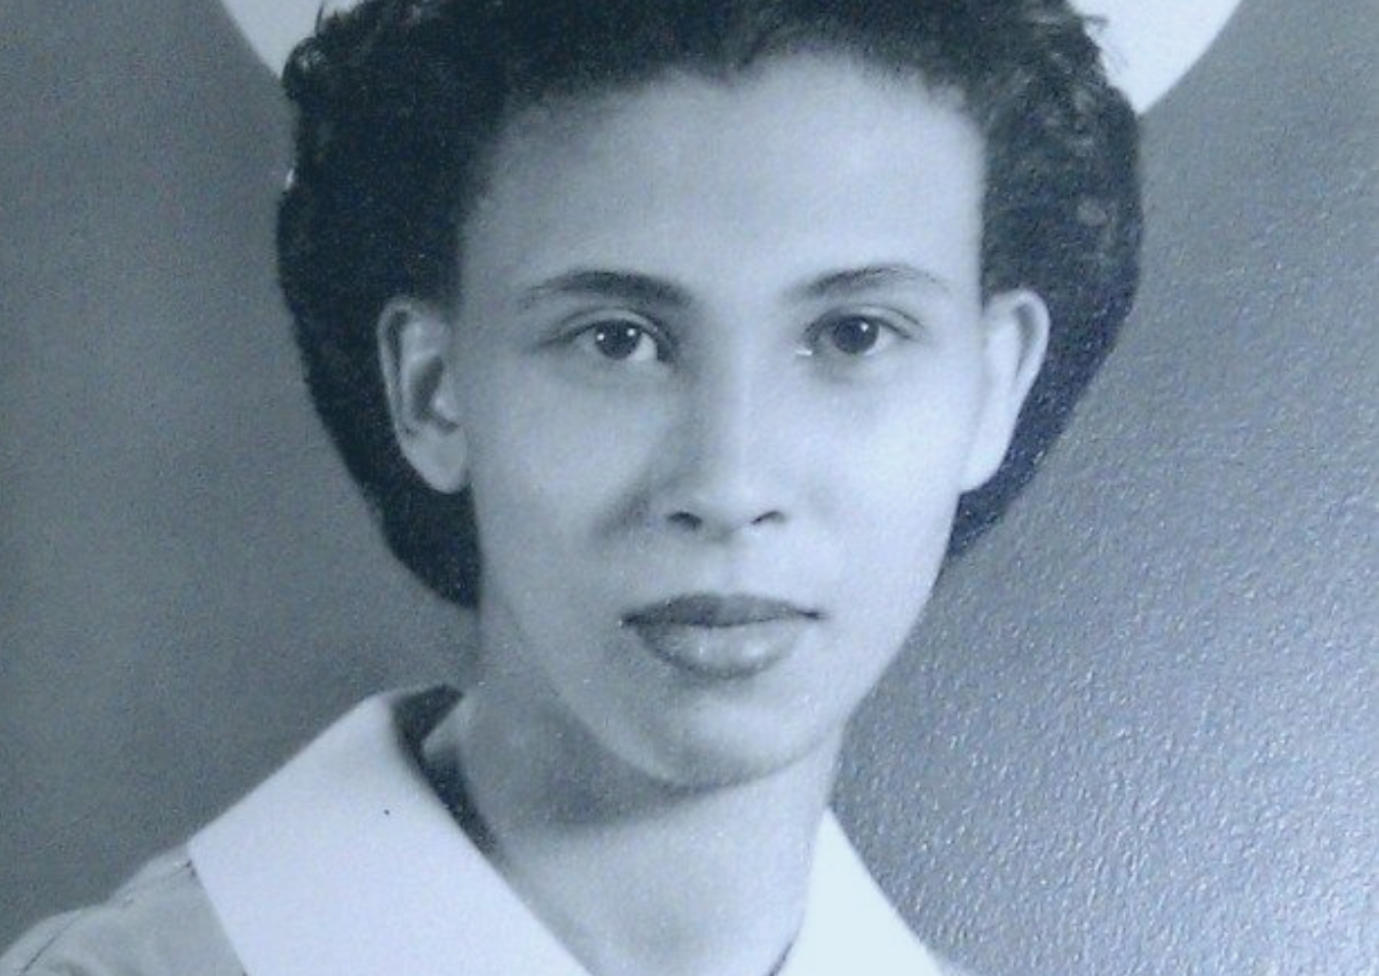
Zipporah Parks Hammond
Make it Right. Let’s get CU Nursing’s first Black graduate inducted into the Colorado Women’s Hall of Fame. After five tries, it’s about time. Discover more about Zippy and why she deserves it.

Executive Summary - March 2021
Zipporah Parks Hammond at the University of Colorado

A selfless, servant Colorado pioneer

Our best-known American heroes are made of lesser stuff. Most people have never heard of Zipporah Parks Hammond because she was a woman and Black. Yet, in her lifetime she blazed trails in the fields of education and healthcare, courageously fought for the elderly and mentally ill, preserved the history of Black people in Denver, and nurtured children paralyzed by polio shunned by others because of their skin color.
Zipporah lived in a time when Blacks and whites did not mingle, and segregation was the norm. And still she found ways to open doors for historically oppressed communities, elevate the status of all women, and make significant contributions to her community and society with class and grace.
They called her Zippy. She was born on March 1, 1922 an only child to parents who set examples of working hard and helping others. Zippy was bright, fearless and precocious. In high school, she wrote essays about the city’s squalid housing and unemployment problem.

Prejudice must be removed and all people in need given equal assistance. About the only way to receive this treatment will be to have well-trained, conscientious Negro workers who will demand fairness for our people. - Zipporah Parks

In 1941, she was accepted into the University of Colorado School of Nursing, the only Black student in a class of 30. Many of her classmates were prejudiced. She couldn’t live on campus, study with white students or get hands-on learning. And because of the color of her skin, some didn’t think she had the mental capacity to learn. But learn she did. In 1946, Zipporah Parks became the university’s first Black nursing school graduate.

Zipporah had vision – a dream of accomplishing something that no other African American woman before her in the history of Colorado had done: to be admitted to and successfully graduate from the nursing program at C.U. In spite of much skepticism from all quarters, she succeeded with aplomb. She fearlessly challenged the status quo and refused to allow the color of her skin to confine her to arbitrary and limited choices routinely conscribed to women of color during her time. - Resource room educator Karen Pauley

When nurses were desperately needed in World War II, Zipporah joined the Cadet Nurse Corps where she was the only Black nurse out of 1600 student nurses.

She began her career as a surgical nurse at Colorado General Hospital in Denver and was then sought out and appointed as chief surgical nurse for the Infantile Paralysis Center at the Tuskegee Institute in Alabama. That’s where she led a team to care for young Black patients with polio. Her work helped establish medical-treatment protocols to correct the impacts of the disease. But in 1947, she contracted tuberculosis. The deadly respiratory illness forced her to return to Denver to get treatment at the National Jewish Hospital.
During her long recovery, she fell in love with another person with TB and married him, officially becoming Zipporah Parks Hammond in 1952. She and Sheldon were married 50 years and had two sons, Stephen and Darrell.

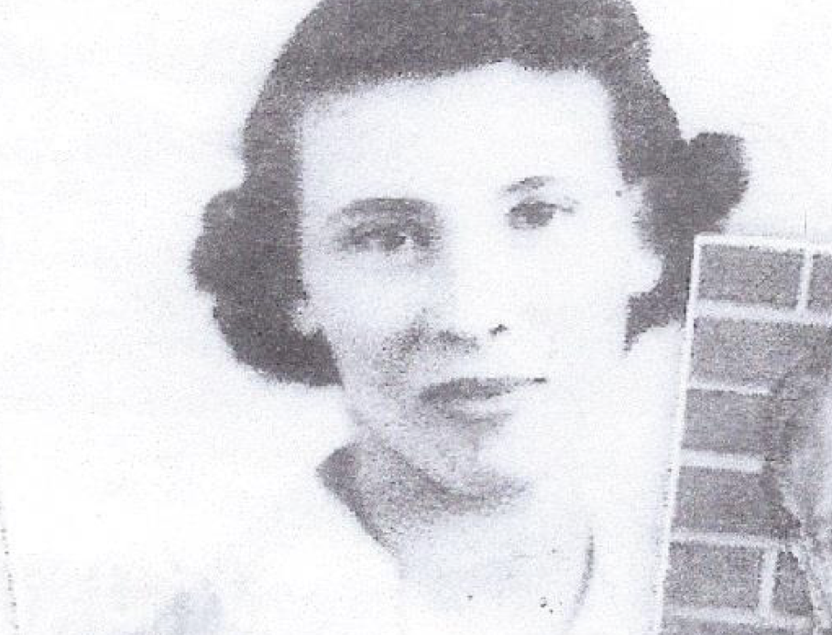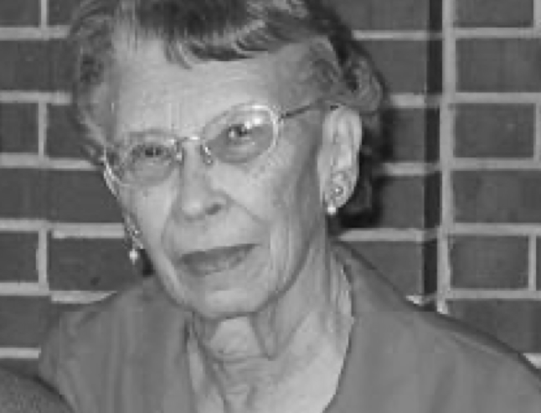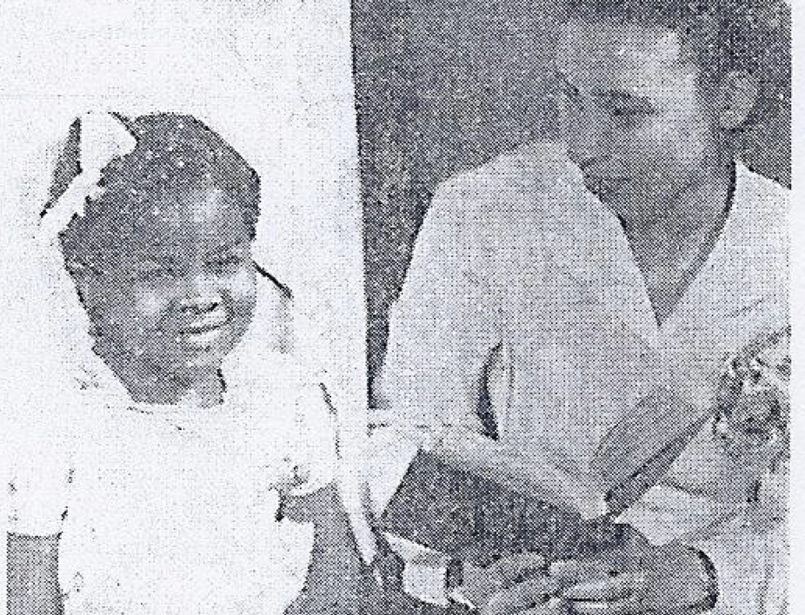

Zipporah Parks Hammond
Before raising a family, Zipporah returned to her alma mater to earn a medical librarian certification. For the next 30 years, Zipporah served in leadership roles as assistant director of medical records at University Hospital and as director of medical records at the now Presbyterian/St. Luke’s as the first Black woman to hold the position. During that time, she also taught and mentored more than 200 young medical students and professionals.
Zippy cared deeply about her childhood community in northeast Denver. She volunteered for 17 years at the Denver Public Library preserving and indexing photographs, artifacts and the rich history of Denver’s Five-Points community, creating a historical legacy.
Her time, her experience, her money; Zippy gave everything she had, always. Despite her modest income, she contributed thousands of dollars for decades to dozens of charitable organizations in Colorado including Mental Health American of Colorado, the Colorado Coalition for the Homeless, Denver Rescue Mission, Senior Support Services, Friends of Manual High School, Gathering Place a Place for Women, Alzheimer's Research and more.
Some have recognized her efforts. The University of Colorado College of Nursing honored Zippy in 2004 with the Diversity Leadership Award for her tenacity, passion and vision. In 2009, Zipporah was honored by her peers as a ‘Living-Legend’ among Black women in Denver who have made significant contributions to their community and society.
When she died in 2011, the CU College of Nursing Alumni Association presented her posthumously with the Pathfinders Award of Black women in Denver for making a significant contribution to her community. The CU College of Nursing also established a memorial nursing scholarship in her name to help other students overcome financial challenges and to recognize volunteer and public service for those in need.

Zipporah’s firsts represent positive and lasting milestones in Colorado history. Her success ultimately broke down barriers and made it easier for women and minorities to enroll in college to pursue nursing as a career. She bettered the health-care and medical-services professions by hoisting others on her shoulders. As a success story, Zipporah set precedence and it became easier for qualified women and minority candidates to pursue their dream of a professional career caring for others. -U.S. Senator Michael F. Bennet

Zipporah’s selfless, servant life deserves to be placed among the other greats in the Colorado Women’s Hall of Fame.
She fought prejudice, bigotry and segregation to attain her college degree, and sacrificed her health and career -- contracting tuberculosis -- while treating patients. Because of the disease, nursing was off limits to her. So, she turned to medical record keeping and became a leader in that field. At every turn, Zipporah persevered giving back to the state and community she loved so much. Through adversity, she always found a constructive way forward.

